DESIGN AND MODELLING OF FOOTWEAR FOR VISUALLY IMPAIRED

A PROJECT REPORT
Submitted by
V.SRIRAM | (20700398)
R.SIRANJEEVEE | (20700397)
G.VARUN | (20700400)
V.VENKAT CHARAN | (20700401)
J.C.KUBER | (20700373)
G.K.YASHWANTHA SAI | (20700406)
In partial fulfilment for the award of the
DIPLOMA
IN
MECHATRONICS ENGINEERING

T.S.SRINIVASAN CENTRE FOR POLYTECHNIC COLLEGE AND ADVANCED TRAINING
No.1, TVS School Road, Vanagaram, Chennai-95.
NOVEMBER 2022
T.S.SRINIVASAN CENTRE FOR POLYTECHNIC COLLEGE AND ADVANCED TRAINING
No.1, TVS School Road, Vanagaram, Chennai-95.
BONAFIDE CERTIFICATE

This is certify that this project report Titled “FOOTWEAR FOR VISUALLY IMPAIRED” is the Bonafide work of Selvan. _______________________who carries out the project work under my guidance. Certified further, that to the best of my knowledge, the work herein does not form part of any other thesis or dissertation on the basis of which a degree or award was conferred on an earlier occasion on this or any other candidate.

Internal guide Head of department

Examination date___________________

Internal examiner External examiner

ACKNOWLEDGEMENT
Any piece of work that has proved its way remains incomplete if the sense of gratitude and respect is not being deemed to those who have proved to be supportive during its development period. Though these words are not enough, they can at least pave way to help understand the feeling of respect and admirance, have for those who have helped the way through.
First and foremost, we would like to thank the Nature & Society for giving us the power to believe in our self and pursue our dreams.
I would like to express my heartfelt thanks to the management without whose genuine support and inspiration this project of mine would not have appeared in reality.
I express my sincere and heartfelt thanks to our Principal Dr. V.V.SENTHILKUMAR M.E, Ph.D. for his constant encourage, invaluable guidance and motivation throughout the course of my project.
I would also extend my heartfelt thanks to my Head of the Department Mrs. S.P.CHITRA and Project Coordinator Mr. R.NANDHA GOPAL, Lecturer for their guidance through the course.
I am equally indebted to express my deep sense of honor to our Guide Mrs. S.P. CHITRA, Lecturer for their unfailing support and cooperation throughout this exercise.
I thank all the faculty member teaching and non-teaching staff members of our institution and management for their kind support.
And also, I would like to express my deep appreciation to my family & friends for their affection, trust and support. They have meant very much to me. I could not have succeeded without them.
I am very honorable to spell my gratitude to my parents and friends who were with me throughout the course.

VISION of CPAT-TVS
To create multi-skilled, technically proficient and highly motivated individuals, who continuously strive for excellence and are committed to the betterment of society.
MISSION of CPAT-TVS
To provide a solid foundation in Engineering concepts and principles.
To create technically competent diploma engineers through the delivery of specially designed curriculum involving additional courses, industrial training and delivery beyond the framework.
To strengthen critical skills and apt attitudes to meet challenges in all endeavors.
DEPARTMENT OF MECHATRONICS ENGINEERING
VISION
To create proficient and multi-skilled Diploma Mechatronics Engineers who
strive for continuous improvement in all endeavors (Automation, Robotics and Maintenance)
MISSION
To intersperse hands-on training in academic curriculum with additional courses and develop multi-disciplinary technical skills
To facilitate quality classroom interactions and Industry - linked holistic training
To install skills to foster sense of excellence, ethical values, competency and flexibility to adapt to the changing requirements of global industries and entrepreneurship.
PROGRAM SPECIFIC OUTCOMES (PSOs)
PSO 1: Ability to solve contemporary issues related to manufacturing, design, and Industrial automation through internship integrated program curriculum that includes training, knowledge, practice and hands on training.
PSO 2: Ability to thrive by higher studies or become an entrepreneur by adapting discipline, effective communication, business economics, managerial skills for the betterment of society.
PROGRAM EDUCATIONAL OBJECTIVES (PEOs)
PEO-I: Practice Mechatronics Engineering concepts in the general stems of automation, robotics and allied engineering sectors.
PEO-II: Continue to learn the advances in Mechatronics Engineering that supports career growth.
PEO-III: Reflect and conduct in a responsible, professional and ethical manner.
PEO-IV: Emerge as leaders in their domain that support societal development

PROGRAM OUTCOMES (POS)
PO.1 Basic and Discipline specific knowledge: Apply knowledge of basic mathematics, science and engineering fundamentals and engineering specialization to solve the engineering problems.
PO.2 Problem analysis: Identify and analyse well-defined engineering problems using codified standard methods.
PO.3 Design/development of solutions: Design solutions for well-defined technical problems and assist with the design of systems components or processes to meet specified needs.
PO.4 Engineering Tools, Experimentation and Testing: Apply modern engineering tools and appropriate technique to conduct standard tests and measurements.
PO.5 Engineering practices for society, sustainability and environment: Apply appropriate technology in context of society, sustainability, environment and ethical practices.
PO.6 Project Management: Use engineering management principles individually, as a team member or a leader to manage projects and effectively communicate about well-defined engineering activities.
PO.7 Life-long learning: Ability to analyze individual needs and engage in updating in the context of technological change

MAPPING PROJECT WITH PROGRAM OUTCOMES

POS | MAPPING | JUSTIFICATION
PO1 | Medium | This project involves fair knowledge in science and mathematics related to physical parameters and design calculated.
PO2 | High | This project involves strong knowledge to Identify and analyze well-defined engineering problems using codified standard methods.
PO3 | Medium | This project involves fair knowledge in core engineering related to automation and electronics with the support of mechanical engineering.
PO4 | High | This Project provides strong knowledge to perform experiments related to Automation by sensors, and Arduino program. The results can be used to solve engineering problems.
PO5 | Medium | This project applies fair knowledge with appropriate technology in context of society, sustainability, environment and ethical practices.
PO6 | High | This project students uses engineering management principles individually and strongly, and as a team member or a leader to manage projects and effectively communicate about well-defined engineering activities.
PO7 | Medium | This Project provides fair knowledge to perform experiments related to future needs and will be platform for the future technological  changes.

ABSTRACT
This project focuses on developing smart shoes for the visually impaired persons. The smart shoe has embedded ultrasound sensors on the toe to warn blind users of obstacles in their path. It can detect potential obstacles located up to four meters in front of the user. The wearer is warned with the help of vibration motor. In order to increase the daily lifetime of the battery, the force exerted during walking is converted to electrical energy to charge the battery while walking using a piezoelectric disc. The built-in batteries effortlessly cope with average daily life, due to this intelligent control system and lasts for a week, depending on its use. The shoe is designed mechanically and components are selected in a way, so as to keep it small, lightweight, simple and comfortable.

INDEX
SI.NO | TITLE | PG.NO.
 | ACKNOWLEDGEMENT | 3
 | ABSTRACT | 7
1 | CHAPTER | 12
 | INTRODUCTION | 13
2 | CHAPTER | 14
 | LITERATURE SURVEY | 15
3 | CHAPTER | 16
 | METHODOLOGY | 17
 | 3.1 EXISITING SYSTEM | 14
 | 3.2 PROPOSED SYSTEM | 18
 | 3.3 BLOCK DIAGRAM | 19
 | 3.4 HARDWARE AND SOFTWARE REQUIREMENTS IDENTIFIED | 19
4 | CHAPTER | 20
 | 4.1 ARDUINO NANO | 21
 | 4.1.1 HISTORY | 22
 | 4.1.2 CIRCUIT DIAGRAM | 22
 | 4.1.3 PIN DIAGRAM | 23
 | 4.1.4 FEATURES | 24
 | 4.1.5 COMMUNICATION | 25
 | 4.1.6 AUTOMATIC (SOFTWARE) RESET | 26
 | 4.1.7 ARDUINO NANO INFO | 27
 | 4.1.8 ARDUINO NANO PROGRAMMING AND COMMUNICATION. | 30
 | 4.2 CHARGING BOARD | 31
 | 4.2.1 PIN DETAILS | 32
 | 4.2.2 CIRCUIT DIAGRAM OF TP4056 LITHIUM ION BATTERY CHARGER | 33
 | 4.2.3 APPLICATIONS | 34
 | 4.3 ULTRASONIC SENSOR | 35
 | 4.3.1 INTRODUCTION TO ULTRASONIC SENSOR | 36
 | 4.3.2 ULTRASONIC SENSOR WORKING PRINCIPLE | 37
 | 4.3.3 TIMING DIAGRAM OF ULTRASONIC SENSOR | 38
 | 4.3.4 HOW TO CALCULATE DISTANCE | 39
 | 4.4 PIEZOELECTRIC SENSOR | 40
 | 4.4.1 APPLICATION | 40
 | 4.4.2 ELECTRICAL PROPERTIES | 43
 | 4.4.3 SENSOR DESIGN | 44
 | 4.4.4 SENSING MATERIAL | 45
 | 4.5 BATTERY | 46
 | 4.5.1 HISTORY | 48
 | 4.5.2 ELECTRO CHEMICAL | 50
 | 4.6 VIBRATION MOTOR | 52
 | 4.7 BRIDGE WAVE RECTIFIER | 54
 | 4.7.1 RECTIFIER | 55
 | 4.7.2 GRAPH | 56
 | 4.8 CONNECTOR | 57
5 | CHAPTER | 59
 | 5.1 ARDUINO NANO PROGRAMMING | 60
 | 5.2 ARDUINO DROID SOFTWARE | 63
 | 5.3 UPLOADING IN ARDINO NANO V3.0 | 63
6 | CHAPTER | 64
 | 6.1 TINKER CAD SOFTWARE | 65
 | 6.1.1 TINKER CAD SIMULATION CIRCUIT | 65
 | 6.1.2 OUTPUT OF THE TINKER CAD SIMULATION | 65
7 | CHAPTER | 66
 | FINALISED SHOE SKETCH | 67
8 | CHAPTER | 68
 | CIRCUIT DIAGRAM | 69
9 | CHAPTER | 70
 | PIEZO DISC CIRCUIT WITH BRIDGE RECTIFIERV | 71
10 | CHAPTER | 72
 | PIEZO DISC ATTACHED TO BOTH SOLE OF THE SHOES | 73
 | 10.1 TOP SIDE OF THE SHOE | 73
 | 10.2 BOTTOM SIDE OF THE SHOE | 74
 | 10.3 RESULT | 74
11 | CHAPTER | 75
 | FINISHED PROJECT | 76
12 | CHAPTER | 77
 | DIFFERENCE BETWEEN COMPONENTS | 78
13 | CHAPTER | 79
 | 13.1 OUR PROJECT CAN BE IMPROVED LIKE THIS | 80
 | 13.2 RESULT AND ANALYSIS | 80
14 | CHAPTER | 81
 | CONCLUSION | 82

CHAPTER – 1

INTRODUCTION
The advancement in technology is increasing day by day and still requires new inventions to make life of people much easier and as engineers it’s our prime duty to develop new technology to enhance the living standard. Every day, we hear about the smart technologies such as smart TV, a smart car etc., so why not smart shoe? Many people suffer from serious visual disability which is preventing them from working independently. Accordingly they require a tool of wide range which helps to make them independent. Smart shoe is simple and better option to help the blind in their orientation and train them to move on their own independently and safely depending on the other remaining senses. This project presents a prototype model and a system concept to provide smart electronic aid for blind people. This system consists of Ultrasonic sensor, microcontroller and a wireless headphone. The project aims to develop an electronic kit to help blind people obstacle free path. If an obstacle comes in the path, an indication would be relayed by one ultrasonic sensor placed inside the shoe; this unit would take the instruction through the microcontroller, which will generate a sound in wireless headphone. A 9V dc battery is also installed in the shoe which gives supply to the circuit.

CHAPTER – 2

LITERATURE SURVEY
- In project titled “INTEGRATED SMART SHOE FOR BLIND PEOPLE” by MR KUMARA B A, The shoe is implemented with Arduino Uno, The drawback are it’s large in size and has many ports
- In project titled “THIRD EYE FOR BLIND PERSON” by MR AZRA BATOOL, shoe is implemented with Arduino NANO, The main drawback is place inside the tongue of the shoe and will get reset while walking
- In project titled “DESIGN AND IMPLEMENTATION OF SMART SHOES FOR BLIND AND VISUALLY IMPAIRED PEOPLE FOR MORE SECURE MOVEMENTS” by MR ABI ZEID DAOU, shoe is implemented with Arduino mega, the main drawback is large in size for the small circuit connection.

- In this proposed system Arduino NANO board is used to reduce space and the board is also small in size and been programmed and removed the reset button so that it will not get reset while walking

- In project titled “SMART ASSISTIVE SHOES FOR BLIND PEOPLE” by MRS ARIBA KHANAM, shoe is implemented with alkaline batteries, the main drawback is it cannot be recharged again and again.

- In this proposed system Lithium-ion is used to recharge again and again.

- In project titled “SMART SHOES FOR BLIND PERSON” by MR KINNARI TAVDE, shoe is implemented with 5V buzzer and it large in size and creates noise pollution.

- In this proposed system vibration motor is used only so the person who wears it will only sense its output.

CHAPTER – 3

METHODOLOGY
3.1 EXISITING SYSTEM
- Arduino Uno looks awkward outside of the shoe and may cause short circuit.
- Arduino Uno circuit wires are seen through the eyes and may also get disconnected because of walking
- They used jumper wires in circuit so that while walking it gets disconnected.
- Arduino Uno is placed on the top of the shoe lays it feels difficult to wear the shoe for the person.
- Arduino NANO board is placed on the top of shoe and may get.
- Arduino mega board is used its way too big to use the board.
- On and off button is placed on the shoe to work the circuit kind of feels difficult to on and off the circuit connection.
- Battery are placed on the top of the shoe and will cause danger.
- Sealed lead acid battery is used on the top of the shoe feels kind of heavy.
- Alkaline battery are used mostly for the project and it cannot be recharged again and again.
- The project mostly used cannot be recharged if the circuit has lithium ion battery also because they don’t have any special charging port.
- Buzzer is added to the most of the circuit and it make public irritating some times.

3.2 PROPOSED SYSTEM
- Our projects Arduino NANO is fitted inside the shoes tongue gap and will never get short circuit because of resin material shoe and also will never get reset because of we removed the reset switch so that when they walk at any ways the board will not get reset and also the circuit is placed inside the shoe so it will not look awkward from outside.
- And also the project circuit are been soldered and added sleeve so that it will not get short circuit inside the shoe tongue.
- We added two lithium ion battery of 3.7V in series so that the battery will give last long life time up to 17Days of discharging time and 6-8Days of charging time with the help of piezo electric disc and it depends on the person walking and also the battery can be placed inside to tongue minimum gap itself.
- We added two male and female connector to the shoe which looks like a lays and if the connector is plug in the circuit gets power.

3.3 BLOCK DIAGRAM
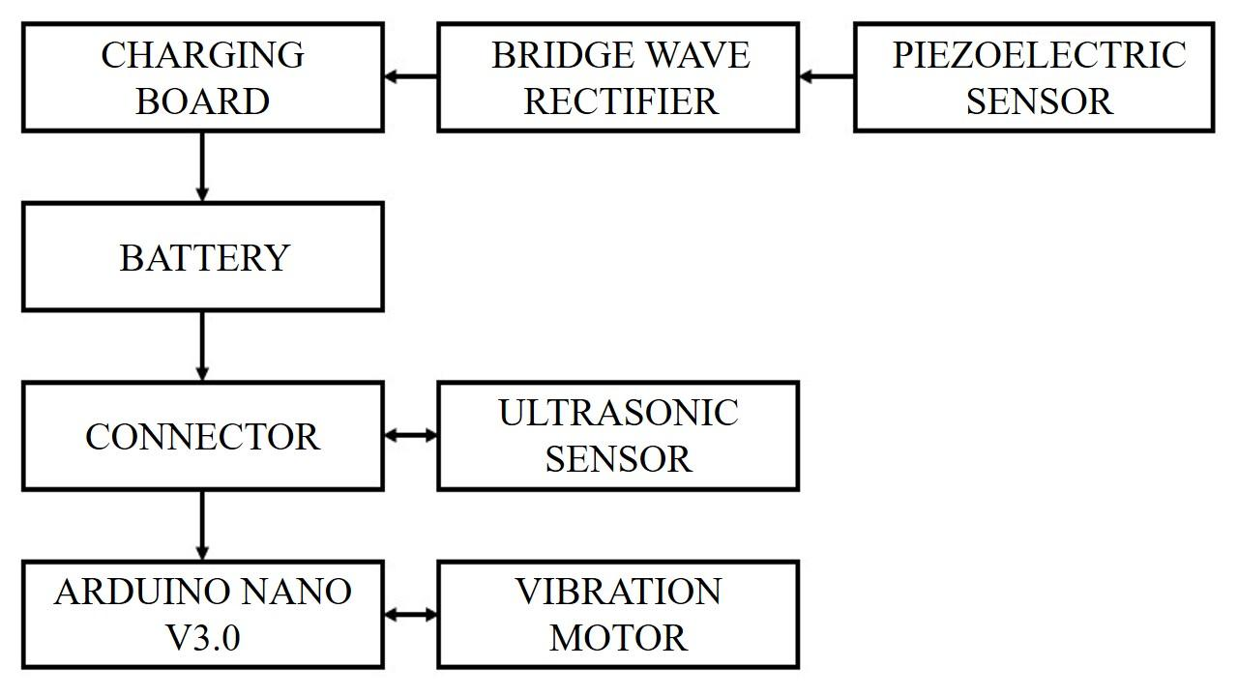

3.4 HARDWARE AND SOFTWARE REQUIREMENTS IDENTIFIED
- ARDUINO NANO
- CHARGING BOARD
- ULTRASONIC SENSOR
- PIEZOELECTRIC SENSOR
- BATTERY
- VIBRATION MOTOR
- BRIDGE WAVE RECTIFIER
- CONNECTOR

CHAPTER – 4

4.1 ARDUINO NANO
The Arduino Nano is a small, complete, and breadboard-friendly board based on the ATmega328P released in 2008. It offers the same connectivity and specs of the Arduino Uno board in a smaller form factor.
The Arduino Nano is equipped with 30 male I/O headers, in a DIP-30-like configuration, which can be programmed using the Arduino Software integrated development environment (IDE), which is common to all Arduino boards and running both online and offline. The board can be powered through a type-B mini-USB cable or from a 9 V battery.
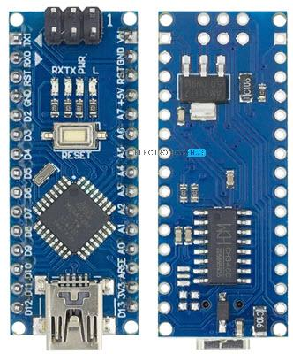

4.1.1 HISTORY
The Arduino Nano was released in 2008. In 2019, Arduino released the Arduino Nano Every, a pin-equivalent evolution of the Nano. It features a more powerful ATmega4809 processor and twice the RAM.

4.1.2 CIRCUIT DIAGRAM

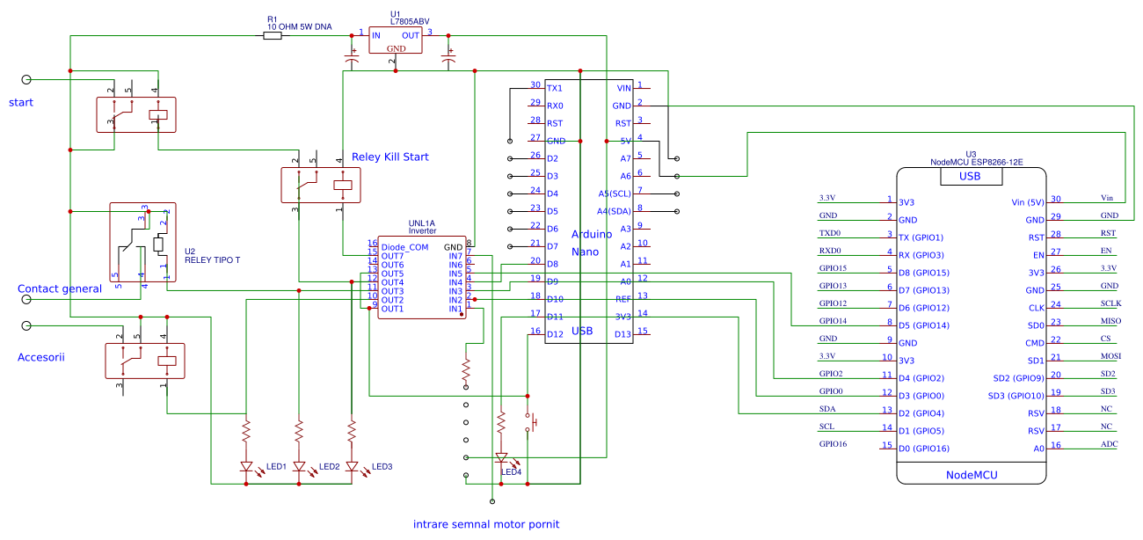
4.1.3 PIN DIAGRAM
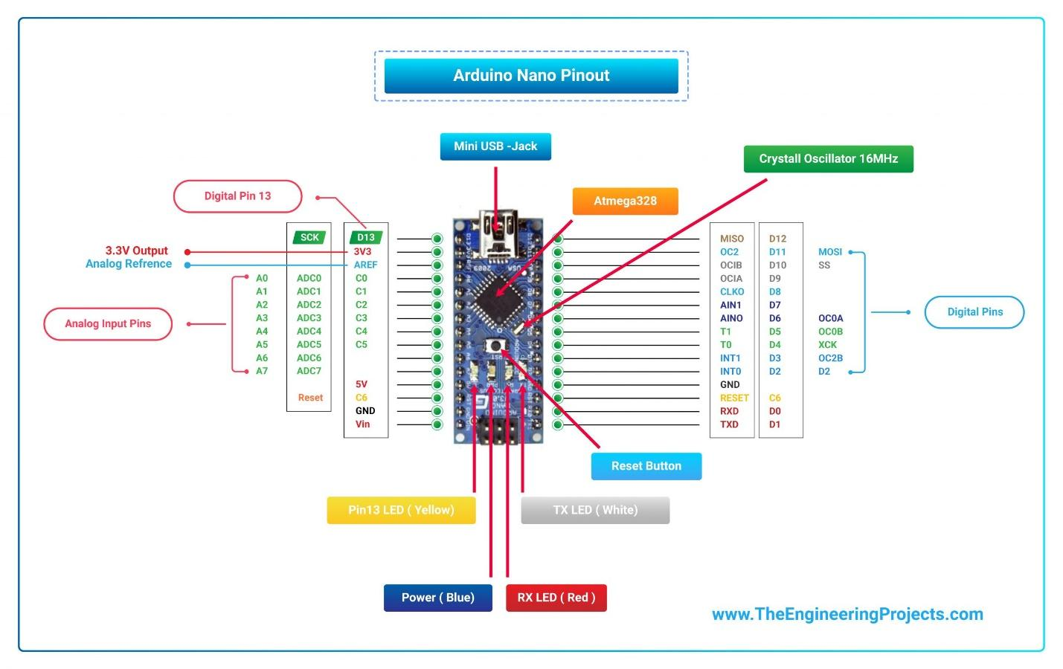

4.1.4 FEATURES
No. | Nano Features | Value
1 | Microcontroller | Atmega328p
2 | Crystal Oscillator | 16MHz
3 | Operating Voltage | 5V
4 | Input Voltage | 6V-12V
5 | Maximum Current Rating | 40mA
6 | USB | Type-B Micro USB
7 | ICSP Header | Yes
8 | DC Power Jack | No
9 | D0 - D13 | Digital Input / Output Pins.
10 | A0 - A7 | Analog Input / Output Pins.
11 | Pin # 3, 5, 6, 9, 10, 11 | Pulse Width Modulation (PWM) Pins.
12 | Pin # 0 (RX) , Pin # 1 (TX) | Serial Communication Pins.
13 | Pin # 10, 11, 12, 13 | SPI Communication Pins.
14 | Pin # A4, A5 | I2C Communication Pins.
15 | Pin # 13 | Built-In LED for Testing.
16 | D2 & D3 | External Interrupt Pins
17 | Serial Port | 1 (Pin#0 is RX, Pin#1 is TX).
18 | I2C Port | 1 (Pin#A4 is SDA, Pin#A5 is SCL).
19 | SPI Port | 1 (Pin#10 is SS, Pin#11 is MOSI, Pin#12 is MISO, Pin#13 is SCK).
20 | Flash Memory | 32KB
21 | SRAM Memory | 2KB
22 | EEPROM | 1KB
- Microcontroller: Microchip ATmega328P
- Operating voltage: 5 volts
- Input voltage: 5 to 20 volts
- Digital I/O pins: 14 (6 optional PWM outputs)
- Analog input pins: 8
- DC per I/O pin: 40 mA
- DC for 3.3 V pin: 50 mA
- Flash memory: 32 KB, of which 2 KB is used by boot loader
- SRAM: 2 KB
- EEPROM: 1 KB
- Clock speed: 16 MHz
- Length: 45 mm
- Width: 18 mm
- Mass: 7 g
- USB: Mini-USB Type-B
- ICSP Header: Yes
- DC Power Jack: No
4.1.5 COMMUNICATION
The Arduino Nano has a number of facilities for communicating with a computer, another Arduino, or other microcontrollers. The ATmega328 provides UART TTL (5V) serial communication, which is available on digital pins 0 (RX) and 1 (TX).
An FTDI FT232RL on the board channels this serial communication over USB and the FTDI drivers (included with the Arduino firmware) provide a virtual com port to software on the computer. The Arduino software includes a serial monitor which allows simple textual data to be sent to and from the Arduino board. The RX and TX LEDs on the board flash when data is being transmitted via the FTDI chip and the USB connection to the computer (but not for serial communication on pins 0 and 1). A Software Serial library allows for serial communication on any of the Nano's digital pins. The ATmega328 also supports I2C and SPI communication. The Arduino software includes the Wire library to simplify use of the I2C bus.

4.1.6 AUTOMATIC (SOFTWARE) RESET
Rather than requiring a physical press of the reset button before an upload, the Arduino Nano is designed in a way that allows it to be reset by software running on a connected computer. One of the hardware flow control lines (DTR) of the FT232RL is connected to the reset line of the ATmega328 via a 100 nan farad capacitor. When this line is asserted (taken low), the reset line drops long enough to reset the chip.
This setup has other implications. When the Nano is connected to a computer running Mac OS X or Linux, it resets each time a connection is made to it from software (via USB). For the following half-second or so, the boot loader is running on the Nano. While it is programmed to ignore malformed data (i.e. anything besides an upload of new code), it will intercept the first few bytes of data sent to the board after a connection is opened.

4.1.7 ARDUINO NANO INFO
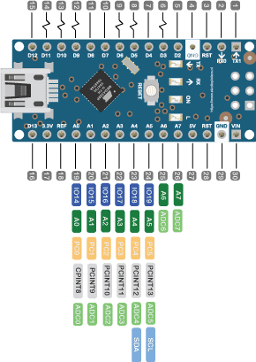
Arduino Nano is a small, complete, flexible and breadboard-friendly Microcontroller board, based on ATmega328p, developed by Arduino.cc in Italy in 2008 and contains 30 male I/O headers, configured in a DIP30 style. Arduino Nano Pinout contains 14 digital pins, 8 analog Pins, 2 Reset Pins & 6 Power Pins. It is programmed using Arduino IDE, which can be downloaded from Arduino Official site. Arduino Nano is simply a smaller version of Arduino UNO, thus both have almost the same functionalities. It comes with an operating voltage of 5V, however, the input voltage can vary from 7 to 12V. Arduino Nano's maximum current rating is 40mA, so the load attached to its pins shouldn't draw current more than that. Each of these Digital & Analog Pins is assigned with multiple functions but their main function is to be configured as Input/Output. Arduino Pins are acted as Input Pins when they are interfaced with sensors, but if you are driving some load then we need to use them as an Output Pin. Functions like pinMode() and digitalWrite() are used to control the operations of digital pins while analogRead() is used to control analog pins. The analog pins come with a total resolution of 10-bits which measures the value from 0 to 5V. Arduino Nano comes with a crystal oscillator of frequency 16 MHz. It is used to produce a clock of precise frequency using constant voltage. There is one limitation of using Arduino Nano i.e. it doesn't come with a DC power jack, which means you cannot supply an external power source through a battery. This board doesn't use standard USB for connection with a computer, instead, it comes with Type-B Micro USB. The tiny size and breadboard-friendly nature make this device an ideal choice for most applications where the size of the electronic components is of great concern. Flash memory is 16KB or 32KB that all depends on the Atmega board i.e Atmega168 comes with 16KB of flash memory while Atmega328 comes with a flash memory of 32KB. Flash memory is used for storing code. The 2KB of memory out of total flash memory is used for a bootloader. The SRAM memory of 2KB is present in Arduino Nano. Arduino Nano has an EEPROM memory of 1KB. It is programmed using Arduino IDE which is an Integrated Development Environment that runs both offline and online. No prior arrangements are required to run the board. All you need is a board, mini USB cable and Arduino IDE software installed on the computer. USB cable is used to transfer the program from the computer to the board. No separate burner is required to compile and burn the program as this board comes with a built-in boot-loader. Each pin on the Nano board comes with a specific function associated with it. We can see the analog pins that can be used as an analog to a digital converter, where A4 and A5 pins can also be used for I2C communication. Similarly, there are 14 digital pins, out of which 6 pins are used for generating PWM.
VIN: It is input power supply voltage to the board when using an external power source of 7 to 12 V.
5V: It is a regulated power supply voltage of the board that is used to power the controller and other components placed on the board.
3V3: This is a minimum voltage generated by the voltage regulator on the nano board.
GND Pin: These are the ground pins on the board. There are multiple ground pins on the board that can be interfaced accordingly when more than one ground pin is required.
Reset Pin: Arduino Nano has 2 reset pins incorporated on the board, making any of these Reset pins LOW will reset the microcontroller. Pin#13: A built-in LED is connected to pin#13 of nano board. This LED is used to check the board i.e. it's working fine or not.
AREF: This pin is used as a reference voltage for the input voltage. Analog Pins: There are 8 analog pins on the board marked as A0 - A7. These pins are used to measure the analog voltage ranging between 0 to 5V.
Digital Pins: Arduino Nano has 14 digital pins starting from D0 to D13. These digital pins are used for interfacing third-party digital sensors and modules with Nano board.
PWM Pins: Arduino Nano has 6 PWM pins, which are Pin#3, 5, 6, 9, 10 and 11. (All are digital pins) These pins are used to generate an 8-bit PWM (Pulse Width Modulation) signal.
External Interrupts: Pin#2 and 3 are used for generating external interrupts normally used in case of emergency, when we need to stop the main program and call important instructions. The main program resumes once interrupt instruction is called and executed.
Serial Pins: These pins are used for serial communication where:
- Pin#0 is RX used for receiving serial data.
- Pin#1 is Tx used for transmitting serial data.
SPI Protocol: Four pins 10(SS->Slave Select), 11(MOSI -> Master Out Slave In), 12(MISO -> Master In Slave Out) and 13(SCK -> Serial Clock) are used for SPI (Serial Peripheral Interface) Protocol. SPI is an interface bus and is mainly used to transfer data between microcontrollers and other peripherals like sensors, registers, and SD cards.
I2C Protocol: I2C communication is developed using A4 and A5 pins, where A4 represents the serial data line (SDA) which carries the data and A5 represents the serial clock line (SCL) which is a clock signal, generated by the master device, used for data synchronization between the devices on an I2C bus.

4.1.8 ARDUINO NANO PROGRAMMING AND COMMUNICATION.
The Nano board comes with the ability to set up communication with other controllers and computers. The serial communication is carried out by the digital pins, Pin 0(Rx) and Pin 1(Tx) where Rx is used for receiving data and Tx is used for the transmission of data. The serial monitor is added to the Arduino IDE, which is used to transmit textual data to or from the board. FTDI drivers are also included in the software which behaves as a virtual com port to the software. The Tx and Rx pins come with an LED which blinks as the data is transmitted between FTDI and USB connection to the computer. Arduino Software Serial Library is used for carrying out serial communication between the board and the computer. Apart from serial communication the Nano board also supports I2C and SPI communication. The Wire Library inside the Arduino Software is accessed to use the I2C bus. The Arduino Nano is programmed by Arduino Software called IDE which is a common software used for almost all types of board available. Simply download the software and select the board you are using. Uploading code to Arduino Nano is quite simple, as there's no need to use any external burner to compile and burn the program into the controller and you can also upload code by using ICSP (In-circuit serial programming header). Arduino board software is equally compatible with Windows, Linux or MAC, however, Windows are preferred to use.

4.2 CHARGING BOARD
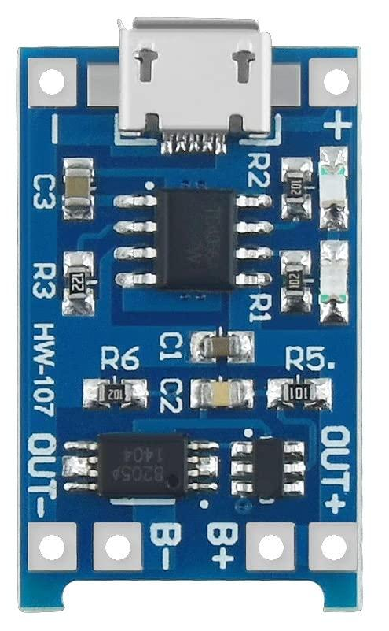
Almost all the electronic devices and gadgets run on battery power now-a-days. You can find many devices like Mobile Phones, Tablets, Laptops, Cameras, etc. that run on battery. Apart from the small devices mentioned above, Cars, Motorcycles, electric vehicles also contain battery and require a battery charger mechanism. And when a battery is involved, a Battery Charger is also involved. Battery Chargers are devices that recharge the batteries by putting energy into them. In this project, I will talk about one such battery charger module for charging Lithium Ion Batteries. It is TP4056 Li-Ion Battery Charger. The TP4056 is a low-cost Lithium Ion battery charger controller IC. It supports a constant current – constant voltage charging mechanism for s single cell Li-Ion Battery. It is available in 8-pin SOP package and requires very minimum external components in order to build a Lithium Ion battery charger circuit. The following image shows the pin diagram of the TP4056 Li-Ion Battery Charger IC. It is an 8-pin IC and the pins are TEMP, PROG, GND, VCC, BAT, , and CE.
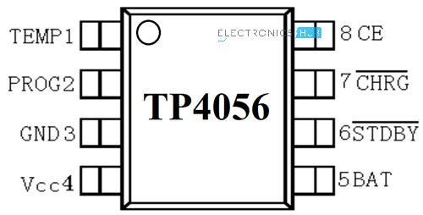
4.2.1 PIN DETAILS
- TEMP: It is an input pin for sensing the temperature. It is connected to the output of the NTC Thermistor in a Battery Pack. Based on the voltage at this pin, you can determine the temperature of the Battery. Battery Temperature is too low if voltage is less than 45% of VCC for more than 0.15S or it is too high if voltage is more than 80% of VCC for the same duration.
- PROG: The charge current to the battery is set by connecting a Resistor called R_{PROG} between this pin and GND. Based on the value of the resistor, the charge current can be anywhere from 130mA to 1000A.
- GND: Ground Pin.
- VCC: It is the power supply pin. TP4056 can support a maximum of 8V at VCC but typically 5V is used.
- BAT: It is the battery connection pin connected to the positive terminal of the battery. The voltage at this pin is 4.2V.
- STDBY: When the battery is completely charged, this pin is pulled low. An LED is connected to this to indicate standby mode.
- CHRG: When the battery is charging, this pin is pulled low. An LED is connected to this pin to indicate battery charging.
- CE: It is an input pin for enabling the chip into operation or disabling it. When a HIGH input is given, the TP4056 is in normal mode and when a HIGH input is given, the IC is disabled.
As mentioned earlier, the PROG (Pin 2) is used to control the charge current to the battery. It is controlled with the help of a resistor called R_{PROG}. The following table shows a list of charging current values for the corresponding R_{PROG} values. This is calculated using the formula I_{BAT} = (V_{PROG} / R_{PROG}) * 1200 and V_{PROG} = 1V.

4.2.2 CIRCUIT DIAGRAM OF TP4056 LITHIUM ION BATTERY CHARGER
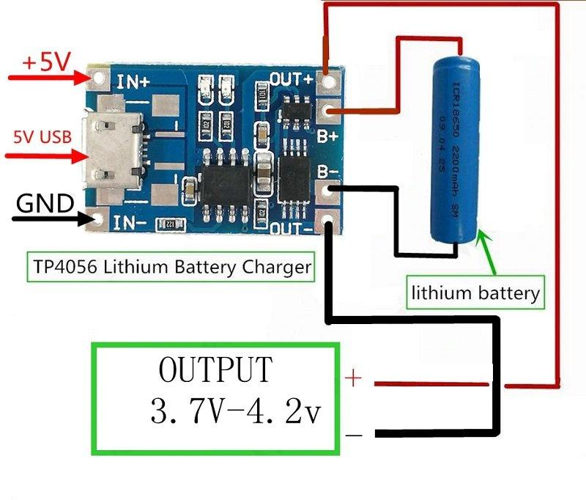
As mentioned earlier, very few external components are required for building a complete Li-Ion Battery Charger circuit using the TP4056 IC. The following image shows the circuit diagram of one such implementation.
The components needed are as follows:
- TP4056 IC
- LEDs x 2
- 1KΩ Resistor x 2
- 0.4Ω Resistor
- 10µF Capacitor x 2
- 1.2KΩ Resistor (R_{PROG})

Based on the TP4056 Lithium Ion Battery Charger Controller IC and the above shown circuit diagram, several Li-Ion Battery Charger Modules are developed. The following image shows the module used in this project. It is a tiny module with all the components mentioned in the above circuit diagram. If you notice, there is a Micro USB connector at the input side of the board. Using this, you can charge a Li-Ion battery from an USB source. Otherwise, there are connectors for Input Voltage as well as terminals for connecting the Battery. The R_{PROG} resistor on this module is of 1.2KΩ. Hence, this module supports a 1A (1000mA) charging current. Rest of the components and parts are mentioned in the image above. If you have 18650 Li-Ion batteries, connect one battery as shown in the following connection diagram. You can charge only one battery at a time. In order to charge the battery, you can either use the IN+ and IN- terminals or provide 5V or alternatively, you can use an USB cable to directly charge from USB supply.
4.2.3 APPLICATIONS
TP4056 Lithium Ion Battery Charger Module (or the IC) can be used in many applications like:
- Mobile Phones
- GPS Devices
- Digital Cameras
- Power Banks
- USB Chargers
- Handheld Computers

4.3 ULTRASONIC SENSOR
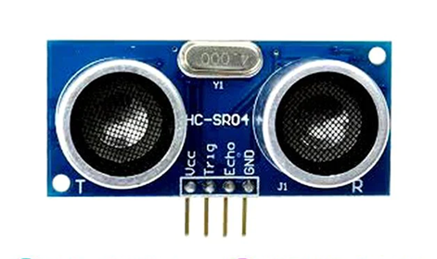
In industrial applications, an ultrasonic detection used to detect hidden tracks, discontinuities in metals, composites, plastics, ceramics, and for water level detection. For this purpose, the laws of physics which are indicating the propagation of sound waves through solid materials have been used since ultrasonic sensors using sound instead of light for detection. In this blog, we are going to learn about the ultrasonic sensor working principle and its applications.

4.3.1 INTRODUCTION TO ULTRASONIC SENSOR
Ultrasonic sensors work by emitting sound waves at a frequency which is too high for humans to hear.
An above image shows the HC-SR-04 ultrasonic sensor which has transmitter, receiver. The pin configuration is,
• VCC – +5 V supply
• TRIG – Trigger input of sensor. Microcontroller applies 10 us trigger pulse to the HC-SR04 ultrasonic module.
• ECHO–Echo output of sensor. Microcontroller reads/monitors this pin to detect the obstacle or to find the distance.
• GND – Ground
Sound is a mechanical wave traveling through the mediums, which may be a solid, or liquid or gas. Sound waves can travel through the mediums with specific velocity depends on the medium of propagation. The sound waves which are having high frequency reflect from boundaries and produce distinctive echo patterns.
Features of an Ultrasonic Sensor
1. Supply voltage: 5V (DC).
2. Supply current: 15mA.
3. Modulation frequency: 40Hz.
4. Output: 0 – 5V (Output high when obstacle detected in range).
5. Beam Angle: Max 15 degrees.
6. Distance: 2 cm – 400 cm.
7. Accuracy: 0.3cm.
8. Communication: Positive TTL pulse.
4.3.2 ULTRASONIC SENSOR WORKING PRINCIPLE
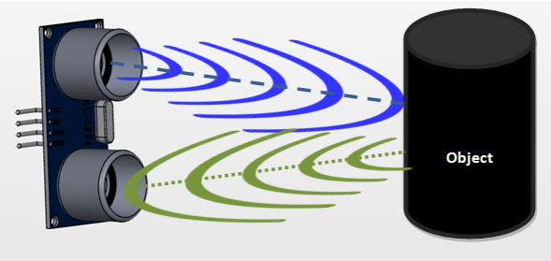
Ultrasonic sensors emit short, high-frequency sound pulses at regular intervals. These propagate in the air at the velocity of sound. If they strike an object, then they reflected back as an echo signals to the sensor, which itself computes the distance to the target based on the time-span between emitting the signal and receiving the echo.
An ultrasonic sensors are excellent at suppressing background interference. Virtually all materials which reflect sound can be detected, regardless of their colour. Even transparent materials or thin foils represent no problem for an ultrasonic sensor.
microsonic ultrasonic sensors are suitable for target distances from 20 mm to 10 m and as they measure the time of flight they can ascertain a measurement with pinpoint accuracy. Some of our sensors can even resolve the signal to an accuracy of 0.025 mm. Ultrasonic sensors can see through dust-laden air and ink mists. Even thin deposits on the sensor membrane do not impair its function.

4.3.3 TIMING DIAGRAM OF ULTRASONIC SENSOR
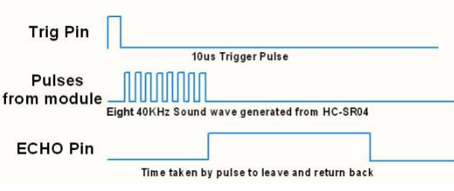

1. First need to transmit trigger pulse of at least 10 us to the HC-SR04 Trig Pin.
2. Then the HC-SR04 automatically sends Eight 40 kHz sound wave and wait for rising edge output at Echo pin.
3. When the rising edge capture occurs at Echo pin, start the Timer and wait for falling edge on Echo pin.
4. As soon as the falling edge captures at the Echo pin, read the count of the Timer. This time count is the time required by the sensor to detect an object and return back from an object.

4.3.4 HOW TO CALCULATE DISTANCE
If you need to measure the specific distance from your sensor, this can be calculated based on this formula:
We know that, Distance= Speed* Time. The speed of sound waves is 343 m/s. So, Total Distance= (343 * Time of hight(Echo) pulse)/2
Total distance is divided by 2 because signal travels from HC-SR04 to object and returns to the module HC-SR-04.
Applications of an Ultrasonic Sensor
• It Uses to avoid and detect obstacles with robots like biped robot, obstacle avoider robot, path finding robot etc.
• It Used to measure the distance within a wide range of 2cm to 400cm.
• Used to map the objects surrounding the sensor by rotating it.
• Depth of certain places like wells, pits etc can be measured since the waves can penetrate through water.

4.4 PIEZOELECTRIC SENSOR
A piezoelectric sensor is a device that uses the piezoelectric effect to measure changes in pressure, acceleration, temperature, strain, or force by converting them to an electrical charge. The prefix piezo- is Greek for 'press' or 'squeeze'.
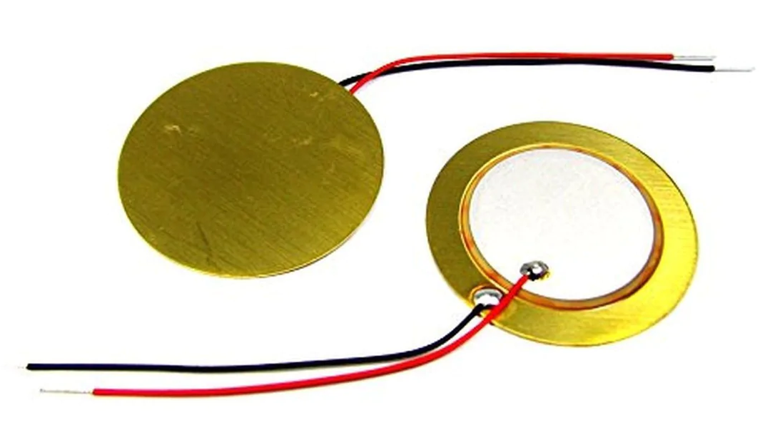
4.4.1 APPLICATION
Piezoelectric sensors are versatile tools for the measurement of various processes. They are used for quality assurance, process control, and for research and development in many industries. Pierre Curie discovered the piezoelectric effect in 1880, but only in the 1950s did manufacturers begin to use the piezoelectric effect in industrial sensing applications. Since then, this measuring principle has been increasingly used, and has become a mature technology with excellent inherent reliability.
They have been successfully used in various applications, such as in medical, aerospace, nuclear instrumentation, and as a tilt sensor in consumer electronics or a pressure sensor in the touch pads of mobile phones. In the automotive industry, piezoelectric elements are used to monitor combustion when developing internal combustion engines. The sensors are either directly mounted into additional holes into the cylinder head or the spark/glow plug is equipped with a built-in miniature piezoelectric sensor.
The rise of piezoelectric technology is directly related to a set of inherent advantages. The high modulus of elasticity of many piezoelectric materials is comparable to that of many metals and goes up to 10⁶ N/m².^{[citation needed]} Even though piezoelectric sensors are electromechanical systems that react to compression, the sensing elements show almost zero deflection. This gives piezoelectric sensors ruggedness, an extremely high natural frequency and an excellent linearity over a wide amplitude range. Additionally, piezoelectric technology is insensitive to electromagnetic fields and radiation, enabling measurements under harsh conditions. Some materials used (especially gallium phosphate or tourmaline) are extremely stable at high temperatures, enabling sensors to have a working range of up to 1000 °C. Tourmaline shows pyroelectricityin addition to the piezoelectric effect; this is the ability to generate an electrical signal when the temperature of the crystal changes. This effect is also common to piezoceramic materials. Gautschi in Piezoelectric Sensorics (2002) offers this comparison table of characteristics of piezo sensor materials vs other types:
Principle | Strain  Sensitivity [V/µε] | Threshold  [µε] | Span to  threshold ratio
Piezoelectric | 5.0 | 0.00001 | 100,000,000
Piezoresistive | 0.0001 | 0.0001 | 2,500,000
Inductive | 0.001 | 0.0005 | 2,000,000
Capacitive | 0.005 | 0.0001 | 750,000
Resistive | 0.000005 | 0.01 | 50,000
One disadvantage of piezoelectric sensors is that they cannot be used for truly static measurements. A static force results in a fixed amount of charge on the piezoelectric material. In conventional readout electronics, imperfect insulating materials and reduction in internal sensor resistance causes a constant loss of electrons and yields a decreasing signal. Elevated temperatures cause an additional drop in internal resistance and sensitivity. The main effect on the piezoelectric effect is that with increasing pressure loads and temperature, the sensitivity reduces due to twin formation. While quartz sensors must be cooled during measurements at temperatures above 300 °C, special types of crystals like GaPO4 gallium phosphate show no twin formation up to the melting point of the material itself. However, it is not true that piezoelectric sensors can only be used for very fast processes or at ambient conditions. In fact, numerous piezoelectric applications produce quasi-static measurements, and other applications work in temperatures higher than 500 °C. Piezoelectric sensors can also be used to determine aromas in the air by simultaneously measuring resonance and capacitance. Computer controlled electronics vastly increase the range of potential applications for piezoelectric sensors. Piezoelectric sensors are also seen in nature. The collagen in bone is piezoelectric, and is thought by some to act as a biological force sensor. Piezoelectricity has also been shown in the collagen of soft tissue such as the Achilles tendon, aortic walls, and heart valves.

4.4.2 ELECTRICAL PROPERTIES
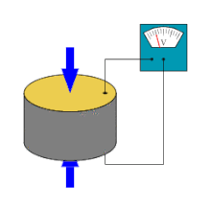
A piezoelectric transducer has very high DC output impedance and can be modeled as a proportional voltage source and filter network. The voltage V at the source is directly proportional to the applied force, pressure, or strain. The output signal is then related to this mechanical force as if it had passed through the equivalent circuit. A detailed model includes the effects of the sensor's mechanical construction and other non-idealities. The inductance L_{m} is due to the seismic mass and inertia of the sensor itself. C_{e} is inversely proportional to the mechanical elasticity of the sensor. C₀ represents the static capacitance of the transducer, resulting from an inertial mass of infinite size. R_{i} is the insulation leakage resistance of the transducer element. If the sensor is connected to a load resistance, this also acts in parallel with the insulation resistance, both increasing the high-pass cutoff frequency. For use as a sensor, the flat region of the frequency response plot is typically used, between the high-pass cutoff and the resonant peak. The load and leakage resistance must be large enough that low frequencies of interest are not lost. A simplified equivalent circuit model can be used in this region, in which C_{s} represents the capacitance of the sensor surface itself, determined by the standard formula for capacitance of parallel plates. It can also be modeled as a charge source in parallel with the source capacitance, with the charge directly proportional to the applied force, as above.

4.4.3 SENSOR DESIGN
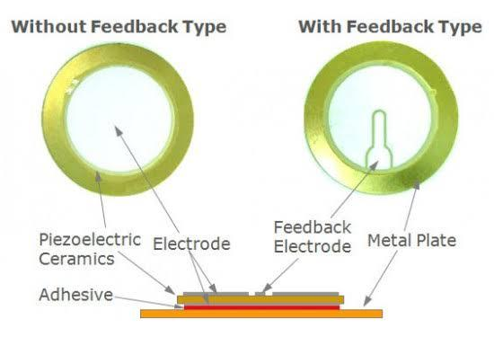
Based on piezoelectric technology various physical quantities can be measured the most common are pressure and acceleration. For pressure sensors, a thin membrane and a massive base is used, ensuring that an applied pressure specifically loads the elements in one direction. For accelerometers, a seismic mass is attached to the crystal elements. When the accelerometer experiences a motion, the invariant seismic mass loads the elements according to Newton's second law of motion .The main difference in working principle between these two cases is the way they apply forces to the sensing elements. In a pressure sensor, a thin membrane transfers the force to the elements, while in accelerometers an attached seismic mass applies the forces. Sensors often tend to be sensitive to more than one physical quantity. Pressure sensors show false signal when they are exposed to vibrations. Sophisticated pressure sensors therefore use acceleration compensation elements in addition to the pressure sensing elements. By carefully matching those elements, the acceleration signal (released from the compensation element) is subtracted from the combined signal of pressure and acceleration to derive the true pressure information. Vibration sensors can also harvest otherwise wasted energy from mechanical vibrations. This is accomplished by using piezoelectric materials to convert mechanical strain into usable electrical energy.
4.4.4 SENSING MATERIAL
Three main groups of materials are used for piezoelectric sensors: piezoelectric ceramics, single crystal materials and thin film piezoelectric materials. The ceramic materials (such as PZT ceramic) have a piezoelectric constant/sensitivity that is roughly two orders of magnitude higher than those of the natural single crystal materials and can be produced by inexpensive sintering processes. The piezoeffect in piezoceramics is "trained", so their high sensitivity degrades over time. This degradation is highly correlated with increased temperature. The less-sensitive, natural, single-crystal materials (gallium phosphate, quartz, tourmaline) have a higher – when carefully handled, almost unlimited – long term stability. There are also new single-crystal materials commercially available such as Lead Magnesium Niobate-Lead Titanate (PMN-PT). These materials offer improved sensitivity over PZT but have a lower maximum operating temperature and are currently more complicated to manufacture due to four compound vs. three compound material PZT. Thin film piezoelectric materials can be manufactured utilizing sputtering, CVD (Chemical vapour deposition), ALD (atomic layer epitaxy) etc. methods. Thin film piezoelectric materials are used in applications where high frequency (> 100 MHz) is utilised in the measurement method and/or small size is favored in the application.

4.5 BATTERY
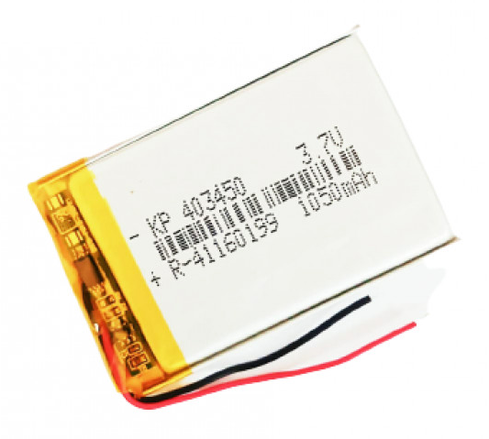
A lithium-ion or Li-ion battery is a type of rechargeable battery which uses the reversible reduction of lithium ions to store energy. It is the predominant battery type used in portable consumer electronics and electric vehicles. It also sees significant use for grid-scale energy storage and military and aerospace applications. Compared to other rechargeable battery technologies, Li-ion batteries have high energy densities, low self-discharge, and no memory effect (although a small memory effect reported in LFP cells has been traced to poorly made cells). Chemistry, performance, cost and safety characteristics vary across types of lithium-ion batteries. Most commercial Li-ion cells use intercalation compounds as the active materials. The anode or negative electrode is usually graphite, although silicon-carbon is also being increasingly used. Cells can be manufactured to prioritize either energy or power density. Handheld electronics mostly use lithium polymer batteries (with a polymer gel as electrolyte), a lithium cobalt oxide (LiCoO
₂) cathode material, and a graphite anode, which together offer a high energy density. Lithium iron phosphate (LiFePO₄), lithium manganese oxide (LiMn₂O₄ spinel, or Li₂MnO₃-based lithium rich layered materials, LMR-NMC), and lithium nickel manganese cobalt oxide (LiNiMnCoO₂ or NMC) may offer longer lives and may have better rate capability. NMC and its derivatives are widely used in the electrification of transport, one of the main technologies (combined with renewable energy) for reducing greenhouse gas emissions from vehicles. M. Stanley Whittingham discovered the concept of intercalation electrodes in the 1970s and created the first rechargeable lithium-ion battery, which was based on a titanium disulfide cathode and a lithium-aluminum anode, although it suffered from safety issues and was never commercialized. John Goodenough expanded on this work in 1980 by using lithium cobalt oxide as a cathode. The first prototype of the modern Li-ion battery, which uses a carbonaceous anode rather than lithium metal, was developed by Akira Yoshino in 1985, which was commercialized by a Sony and Asahi Kasei team led by Yoshio Nishi in 1991. Lithium-ion batteries can be a safety hazard if not properly engineered and manufactured since cells have flammable electrolytes and if damaged or incorrectly charged, can lead to explosions and fires. Much development has made progress in manufacturing safe Lithium-ion batteries. Lithium Ion All Solid State Batteries are being developed to eliminate the flammable electrolyte. Improperly recycled batteries can create toxic waste, especially from toxic metals and are at risk of fire. Moreover, both lithium and other key strategic minerals used in batteries have significant issues at extraction, with lithium being water intensive in often arid regions and other minerals often being conflict minerals such as cobalt. Both environmental issues have encouraged some researchers to improve mineral efficiency and alternatives such as iron-air batteries. Research areas for lithium-ion batteries include extending lifetime, increasing energy density, improving safety, reducing cost, and increasing charging speed, among others. Research has been under way in the area of non-flammable electrolytes as a pathway to increased safety based on the flammability and volatility of the organic solvents used in the typical electrolyte. Strategies include aqueous lithium-ion batteries, ceramic solid electrolytes, polymer electrolytes, ionic liquids, and heavily fluorinated systems.

4.5.1 HISTORY
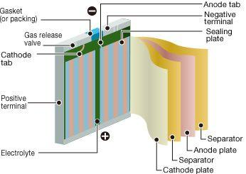
Research on rechargeable Li-ion batteries dates to the 1960s; one of the earliest examples is a CuF₂/Li battery developed by NASA in 1965. The breakthrough that produced the earliest form of the modern Li-ion battery was made by British chemist M. Stanley Whittingham in 1974, who first used titanium disulfide (TiS₂) as a cathode material, which has a layered structure that can take in lithium ions without significant changes to its crystal structure. Exxon tried to commercialize this battery in the late 1970s, but found the synthesis expensive and complex, as TiS₂ is sensitive to moisture and releases toxic H₂S gas on contact with water. More prohibitively, the batteries were also prone to spontaneously catch fire due to the presence of metallic lithium in the cells. For this, and other reasons, Exxon discontinued development of Whittingham's lithium-titanium disulfide battery. In 1980 working in separate groups Ned A. Godshall et al., and, shortly thereafter, Koichi Mizushima and John B. Goodenough, after testing a range of alternative materials, replaced TiS₂ with lithium cobalt oxide (LiCoO₂, or LCO), which has a similar layered structure but offers a higher voltage and is much more stable in air. This material would later be used in the first commercial Li-ion battery, although it did not, on its own, resolve the persistent issue of flammability. The same year, Rachid Yazami demonstrated the reversible electrochemical intercalation of lithium in graphite, and invented the lithium graphite electrode (anode). These early attempts to develop rechargeable Li-ion batteries used lithium metal anodes, which were ultimately abandoned due to safety concerns, as lithium metal is unstable and prone to dendrite formation, which can cause short-circuiting. The eventual solution was to use an intercalation anode, similar to that used for the cathode, which prevents the formation of lithium metal during battery charging. A variety of anode materials were studied; in 1987, Akira Yoshino patented what would become the first commercial lithium-ion battery using an anode of "soft carbon" (a charcoal-like material) along with Goodenough's previously reported LCO cathode and a carbonate ester-based electrolyte. In 1991, using Yoshino's design, Sony began producing and selling the world's first rechargeable lithium-ion batteries. The following year, a joint venture between Toshiba and Asashi Kasei Co. also released their lithium-ion battery. Significant improvements in energy density were achieved in the 1990s by replacing the soft carbon anode first with hard carbon and later with graphite, a concept originally proposed by Jürgen Otto Besenhard in 1974 but considered unfeasible due to unresolved incompatibilities with the electrolytes then in use. In 2012 John B. Goodenough, Rachid Yazami and Akira Yoshino received the 2012 IEEE Medal for Environmental and Safety Technologies for developing the lithium-ion battery; Goodenough, Whittingham, and Yoshino were awarded the 2019 Nobel Prize in Chemistry "for the development of lithium-ion batteries".In 2010, global lithium-ion battery production capacity was 20 gigawatt-hours. By 2016, it was 28 GWh, with 16.4 GWh in China. Global production capacity was 767 GWh in 2020, with China accounting for 75%. Production in 2021 is estimated by various sources to be between 200 and 600 GWh, and predictions for 2023 range from 400 to 1,100 GWh.

4.5.2 ELECTRO CHEMICAL
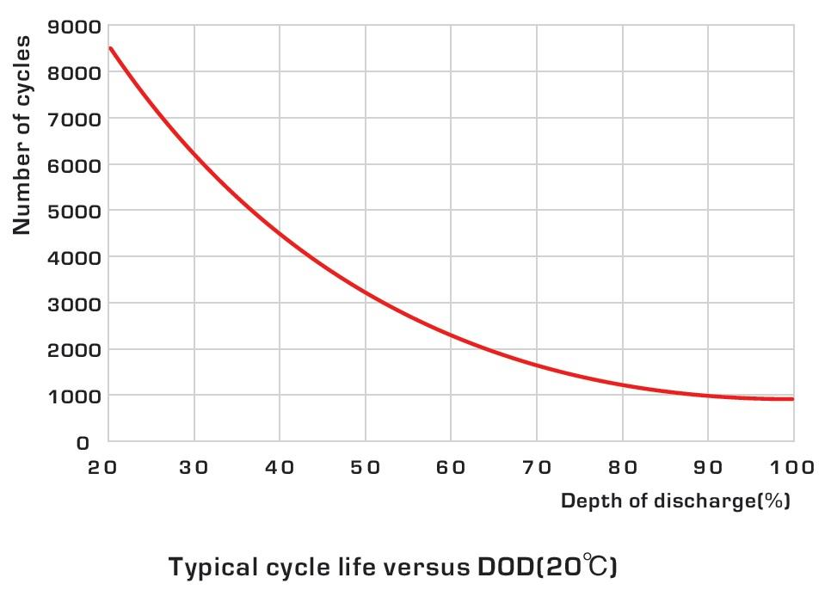
The reactants in the electrochemical reactions in a lithium-ion cell are materials of anode and cathode, both of which are compounds containing lithium atoms. During discharge, an oxidation half-reaction at the anode produces positively charged lithium ions and negatively charged electrons. The oxidation half-reaction may also produce uncharged material that remains at the anode. Lithium ions move through the electrolyte, electrons move through the external circuit, and then they recombine at the cathode (together with the cathode material) in a reduction half-reaction. The electrolyte and external circuit provide conductive media for lithium ions and electrons, respectively, but do not partake in the electrochemical reaction. During discharge, electrons flow from the negative electrode (anode) towards the positive electrode (cathode) through the external circuit. The reactions during discharge lower the chemical potential of the cell, so discharging transfers energy from the cell to wherever the electric current dissipates its energy, mostly in the external circuit. During charging these reactions and transports go in the opposite direction: electrons move from the positive electrode to the negative electrode through the external circuit. To charge the cell the external circuit has to provide electric energy. This energy is then stored as chemical energy in the cell (with some loss, e. g. due to coulombic efficiency lower than 1).Both electrodes allow lithium ions to move in and out of their structures with a process called insertion (intercalation) or extraction (deintercalation), respectively.As the lithium ions "rock" back and forth between the two electrodes, these batteries are also known as "rocking-chair batteries" or "swing batteries" (a term given by some European industries).

4.6 VIBRATION MOTOR

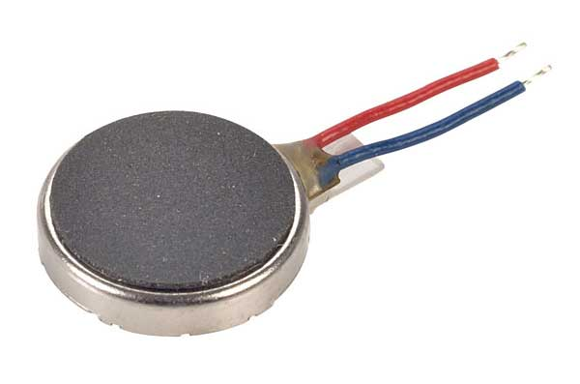
A vibrator is an electromechanical device that takes a DC electrical supply and converts it into pulses that can be fed into a transformer. It is similar in purpose (although greatly different in operation) to the solid-state power inverter. Before the development of switch-mode power supplies and the introduction of semiconductor devices operating off low voltage, there was a requirement to generate voltages of about 50 to 250 V DC from a vehicle's battery. A vibrator was used to provide pulsating DC which could be converted to a higher voltage with a transformer, rectified, and filtered to create higher-voltage DC. It is essentially a relay using normally closed contacts to supply power to the relay coil, thus immediately breaking the connection, only to be reconnected very quickly through the normally closed contacts. It happens so rapidly it vibrates, and sounds like a buzzer. This same rapidly pulsing contact applies the rising and falling DC voltage to the transformer which can step it up to a higher voltage. The primary use for this type of circuit was to operate vacuum tube radios in vehicles, but it also saw use with other mobile electronic devices with a 6 or 12 V accumulator, especially in places with no mains electricity supply such as farms. These vibrator power supplies became popular in the 1940s, replacing more bulky motor-generator systems for the generation of AC voltages for such applications. Vacuum tubes require plate voltages ranging from about 45 volts to 250 volts in electronic devices such as radios. For portable radios, hearing aids and similar equipment, B batteries were manufactured with various voltage ratings. In order to provide the necessary voltage for a radio from the typical 6 or 12 volt DC supply available in a car or from a farm lighting battery, it was necessary to convert the steady DC supply to a pulsating DC and use a transformer to increase the voltage. Vibrators often experienced mechanical malfunctions, being constantly in motion, such as the springs losing tension, and the contact points wearing down. As tubes began to be replaced by transistor based electrical systems, the need to generate such high voltages began to diminish. Mechanical vibrators fell out of production near the end of the 20th century, but solid-state electronic vibrators are still manufactured to be backwards compatible with older units.
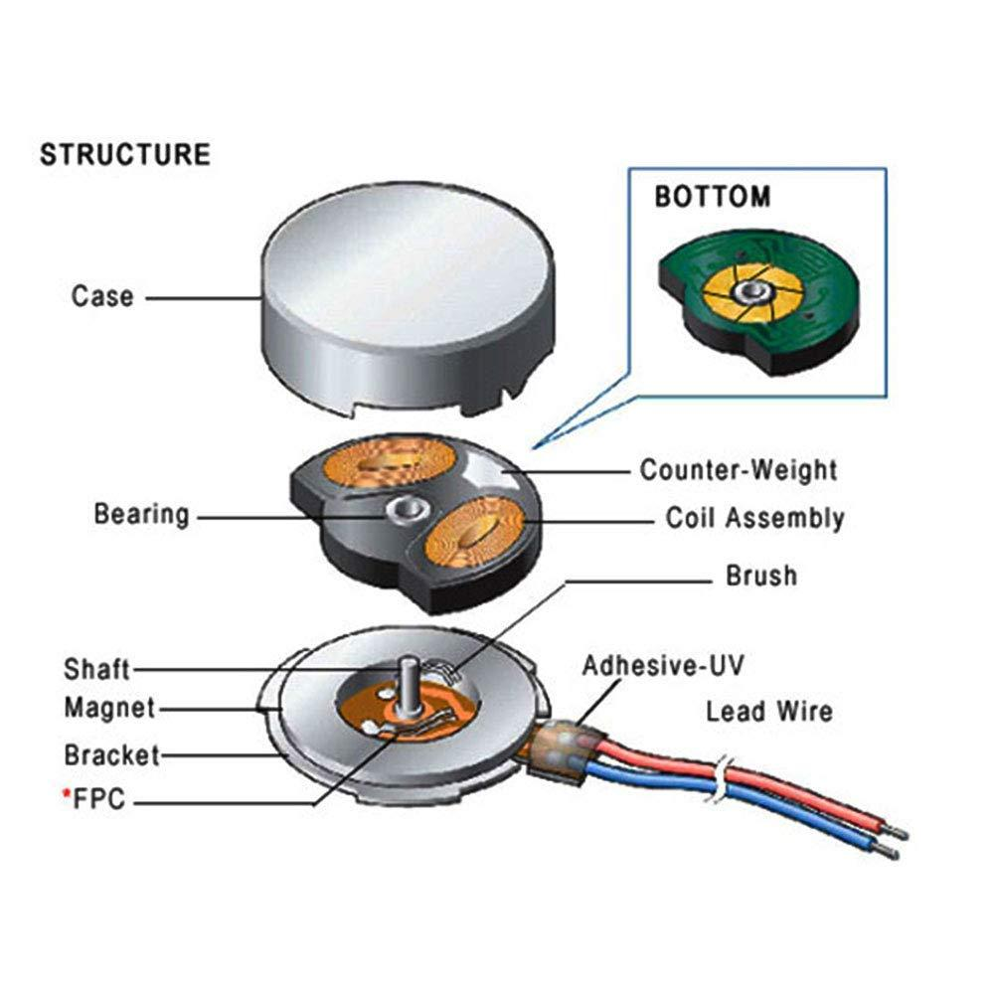

4.7 BRIDGE WAVE RECTIFIER
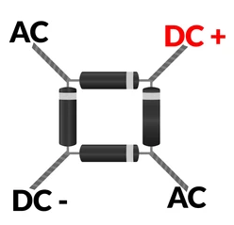
A diode bridge is a bridge rectifier circuit of four diodes that is used in the process of converting alternating current (AC) from the input terminals to direct current (DC, i.e. fixed polarity) on the output terminals. Its function is to convert the negative-going AC pulses into positive going pulses, after which a low-pass filter can be used to smooth the result into DC. When used in its most common application, for conversion of an alternating-current (AC) input into a direct-current (DC) output, it is known as a bridge rectifier. A bridge rectifier provides full-wave rectification from a two-wire AC input, resulting in lower cost and weight as compared to a rectifier with a three-wire input from a transformer with a center-tapped secondary winding. The essential feature of a diode bridge is that the polarity of the output is the same regardless of the polarity at the input. The diode bridge circuit was invented by Polish electrotechnician Karol Pollak and patented in December 1895 in Great Britain and in January 1896 in Germany. In 1897, the German physicist Leo Graetz independently invented and published a similar circuit. Today the circuit is sometimes referred to as a Graetz circuit or Graetz bridge. Prior to the availability of integrated circuits, a bridge rectifier was constructed from "discrete components", i.e., separate diodes. Since about 1950, a single four-terminal component containing the four diodes connected in a bridge configuration became a standard commercial component and is now available with various voltage and current ratings.
4.7.1 RECTIFIER
In the diagrams below, when the input connected to the left corner of the diamond is positive, and the input connected to the right corner is negative, current flows from the upper supply terminal to the right along the red (positive) path to the output and returns to the lower supply terminal through the blue (negative) path.
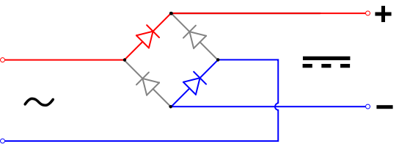
When the input connected to the left corner is negative, and the input connected to the right corner is positive, current flows from the lower supply terminal to the right along the red (positive) path to the output and returns to the upper supply terminal through the blue (negative) path.
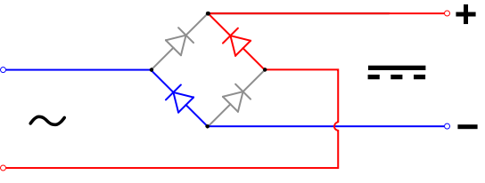
In each case, the upper right output remains positive,^{[11]} and lower right output negative. Since this is true whether the input is AC or DC, this circuit not only produces a DC output from an AC input, it can also provide what is sometimes called “reverse-polarity protection”. That is, it permits normal functioning of DC-powered equipment when batteries have been installed backwards, or when the leads (wires) from a DC power source have been reversed, and protects the equipment from potential damage caused by reverse polarity. Alternatives to the diode-bridge full-wave rectifiers are the center-tapped transformer and double-diode rectifier, and voltage doubler rectifier using two diodes and two capacitors in a bridge topology.

4.7.2 GRAPH
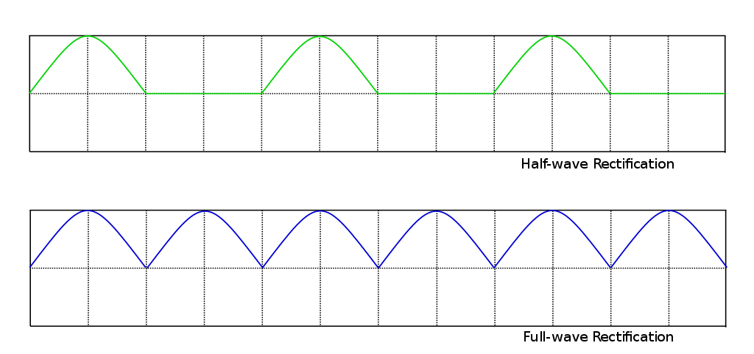
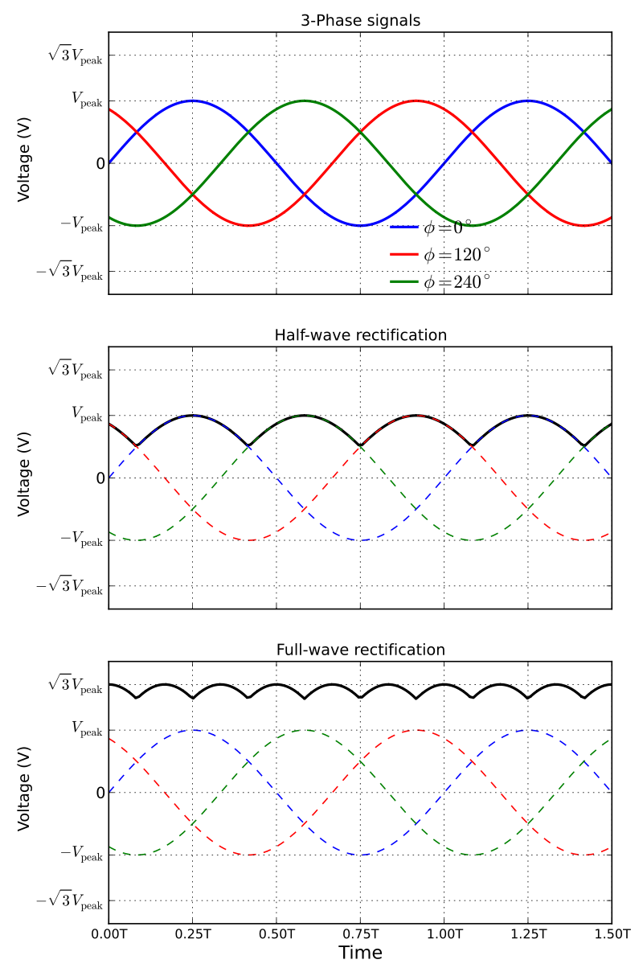

4.8 CONNECTOR

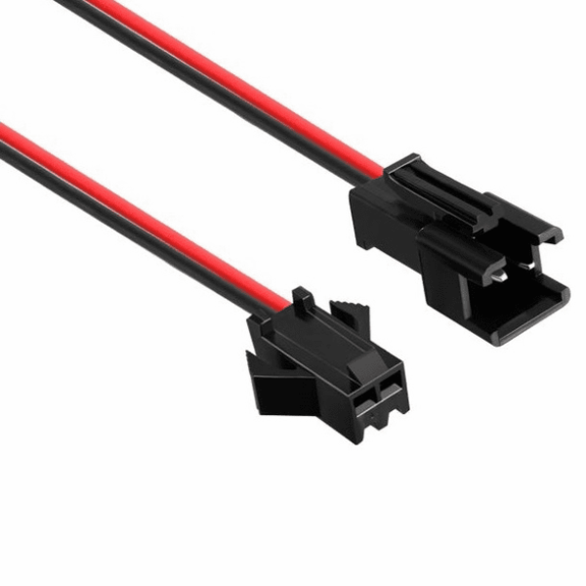
Components of an electrical circuit are electrically connected if an electric current can run between them through an electrical conductor. An electrical connector is an electromechanical device used to create an electrical connection between parts of an electrical circuit, or between different electrical circuits, thereby joining them into a larger circuit. Most electrical connectors have a gender – i.e. the male component, called a plug, connects to the female component, or socket. The connection may be removable (as for portable equipment), require a tool for assembly and removal, or serve as a permanent electrical joint between two points. An adapter can be used to join dissimilar connectors. Thousands of configurations of connectors are manufactured for power, data, and audiovisual applications.

Electrical connectors can be divided into four basic categories, differentiated by their function:
- inline or cable connectors permanently attached to a cable, so it can be plugged into another terminal (either a stationary instrument or another cable)
- Chassis or panel connectors permanently attached to a piece of equipment so users can connect a cable to a stationary device
- PCB mount connectors soldered to a printed circuit board, providing a point for cable or wire attachment. (e.g. pin headers, screw terminals, board-to-board connectors)
- Splice or butt connectors (primarily insulation displacement connectors) that permanently join two lengths of wire or cable
In computing, electrical connectors are considered a physical interface and constitute part of the physical layer in the OSI model of networking.

CHAPTER – 5

5.1 ARDUINO NANO PROGRAMMING
We have already discussed the popular Arduino Boards, Arduino IDEs, and Installation process of the Arduino software. We learned that Arduino IDE (Integrated Development Environment) allows us to draw the sketch and upload it to the various Arduino boards using code. The code is written in a simple programming language similar to C and C++.

/*Modified by
* Blue and Black Flame Master, BBFM15
*/

#define pingPin 2 //trig pin of sr04
#define echoPin 3
void setup()
{
Serial.begin(9600); // Starting Serial Terminal
pinMode(pingPin,OUTPUT);
pinMode(echoPin,INPUT);
pinMode(12,OUTPUT); //pin12 is used as GND pin for motor since arduino nano has only two GND pins
pinMode(A3,OUTPUT); //pin A3 provides the output on motor
}
void loop()
{
long duration, cm;
digitalWrite(12, LOW); //motor GND is always low
//send a signal at ping pin at an interval of 0.002 seconds to check for an object
digitalWrite(pingPin, LOW);
delayMicroseconds(2);
digitalWrite(pingPin, HIGH);
delayMicroseconds(10);
digitalWrite(pingPin, LOW);
duration = pulseIn(echoPin, HIGH); //check time using pulseIn function

cm = microsecondsToCentimeters(duration); //functin call to find distance

/* Serial.print(cm);
Serial.print("cm");
Serial.println();
delay(100);

for debugging
*/

if (cm<30&&cm>20)
{analogWrite(A3,255);
delay(1000);
analogWrite(A3,0);
delay(1000); } //vibration motor every second if obstacle distance is between 20-30cm.
else if (cm<20&&cm>10) {analogWrite(A3,255);
delay(500);
analogWrite(A3,0);
delay(500); } //vibration motor every 0.5 seconds if obstacle distance is between 10-20cm.

else if (cm<10&&cm>0) {analogWrite(A3,255);
delay(100);
analogWrite(A3,0);
delay(100); } //vibration motor every 0.1 seconds if obstacle distance is between 0-10cm.

else analogWrite(A3,0); //do not sound the motor
}
//function to return distance in cm from microseconds
long microsecondsToCentimeters(long microseconds)
{
return microseconds / 29 / 2;
}

5.2 ARDUINO DROID SOFTWARE
Using ArduinoDroid, you can open and edit Arduino sketches, use the sketch navigator, and compile or upload sketches. There's a built-in keyboard, code syntax highlighting for reading code easier, and real-time diagnostics which helps when troubleshooting errors.

5.3 UPLOADING IN ARDINO NANO V3.0

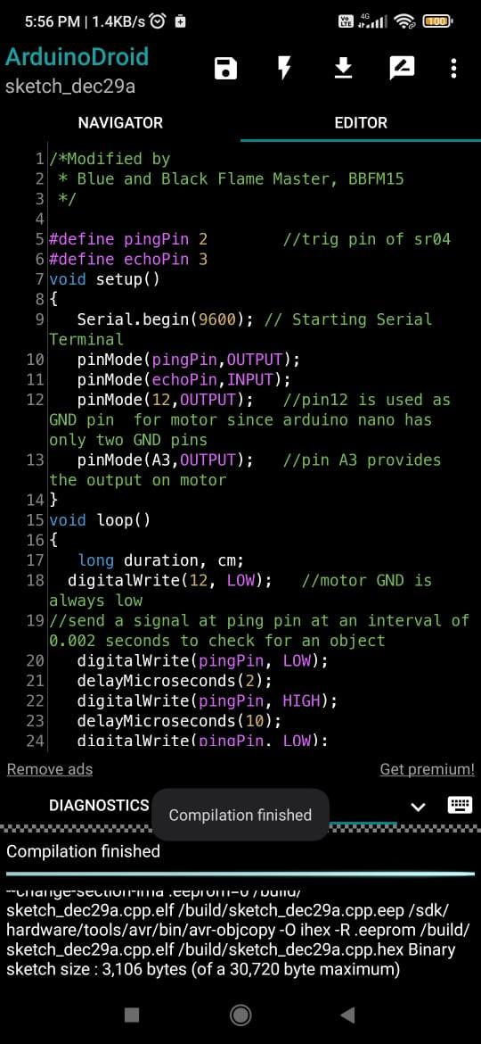

CHAPTER – 6

6.1 TINKER CAD SOFTWARE
6.1.1 TINKER CAD SIMULATION CIRCUIT
We are checking the working model of the circuit using tinker cad and checking the basic circuit and done programming
6.1.2 OUTPUT OF THE TINKER CAD SIMULATION

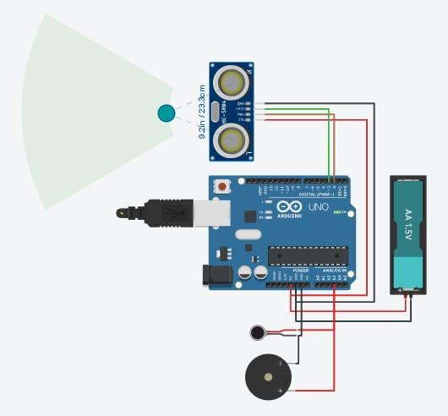

CHAPTER – 7

FINALISED SHOE SKETCH

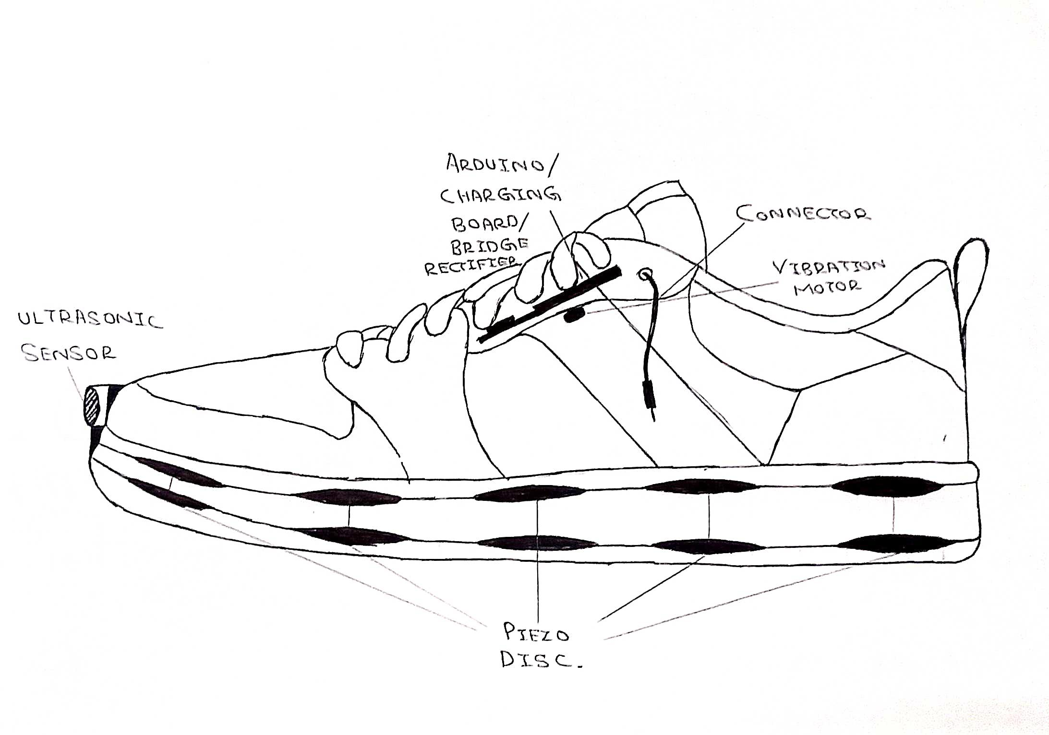

CHAPTER – 8

CIRCUIT DIAGRAM

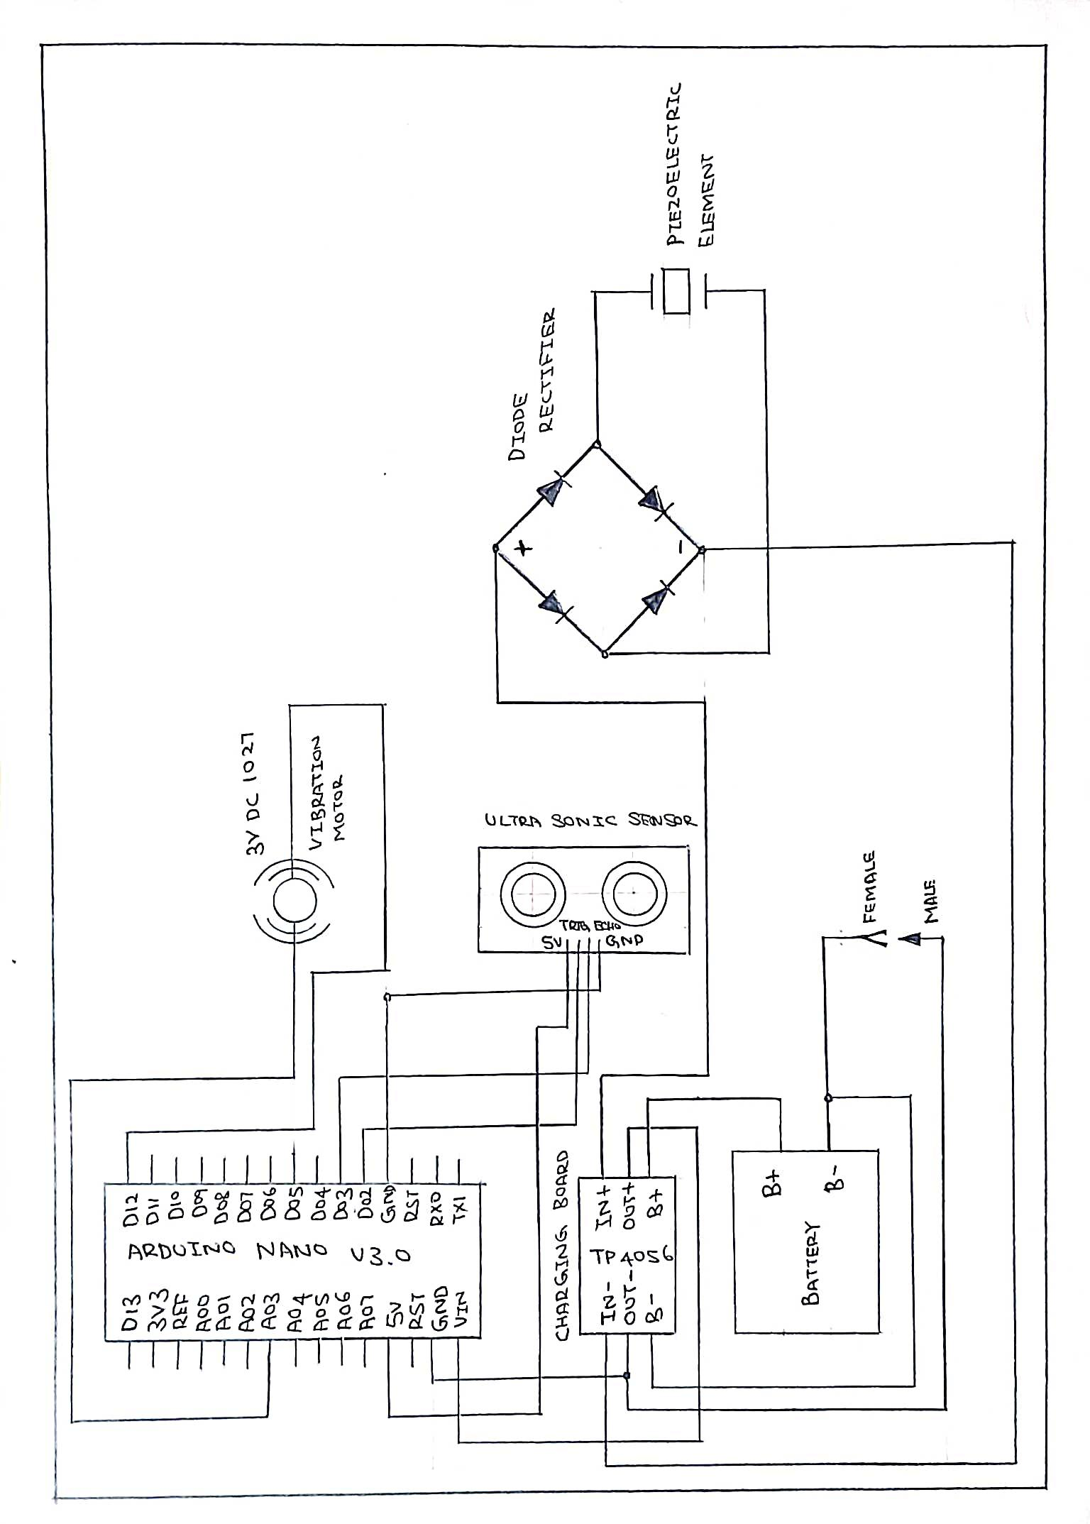

CHAPTER – 9

PIEZO DISC CIRCUIT WITH BRIDGE RECTIFIER

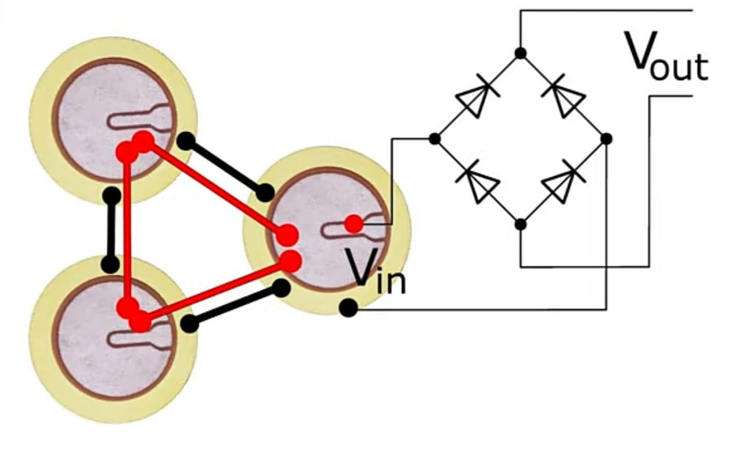

CHAPTER – 10

PIEZO DISC ATTACHED TO BOTH SOLE OF THE SHOES
10.1 TOP SIDE OF THE SHOE
The current produced in the top piezo disc is 64.8mA.
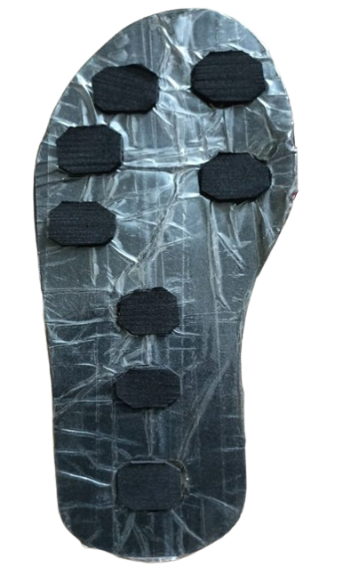

10.2 BOTTOM SIDE OF THE SHOE
The current produced in the bottom piezo disc is 66mA.
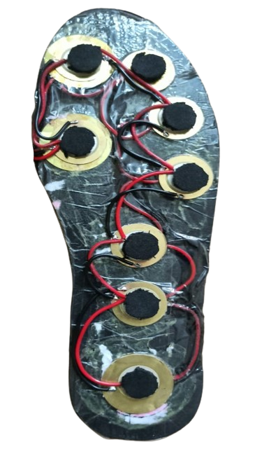

10.3 RESULT
Per day 7.776 V is produced by both the side of piezo disc of daily life.

CHAPTER – 11

FINISHED PROJECT
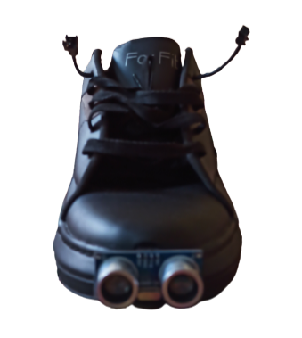

CHAPTER – 12

DIFFERENCE BETWEEN COMPONENTS

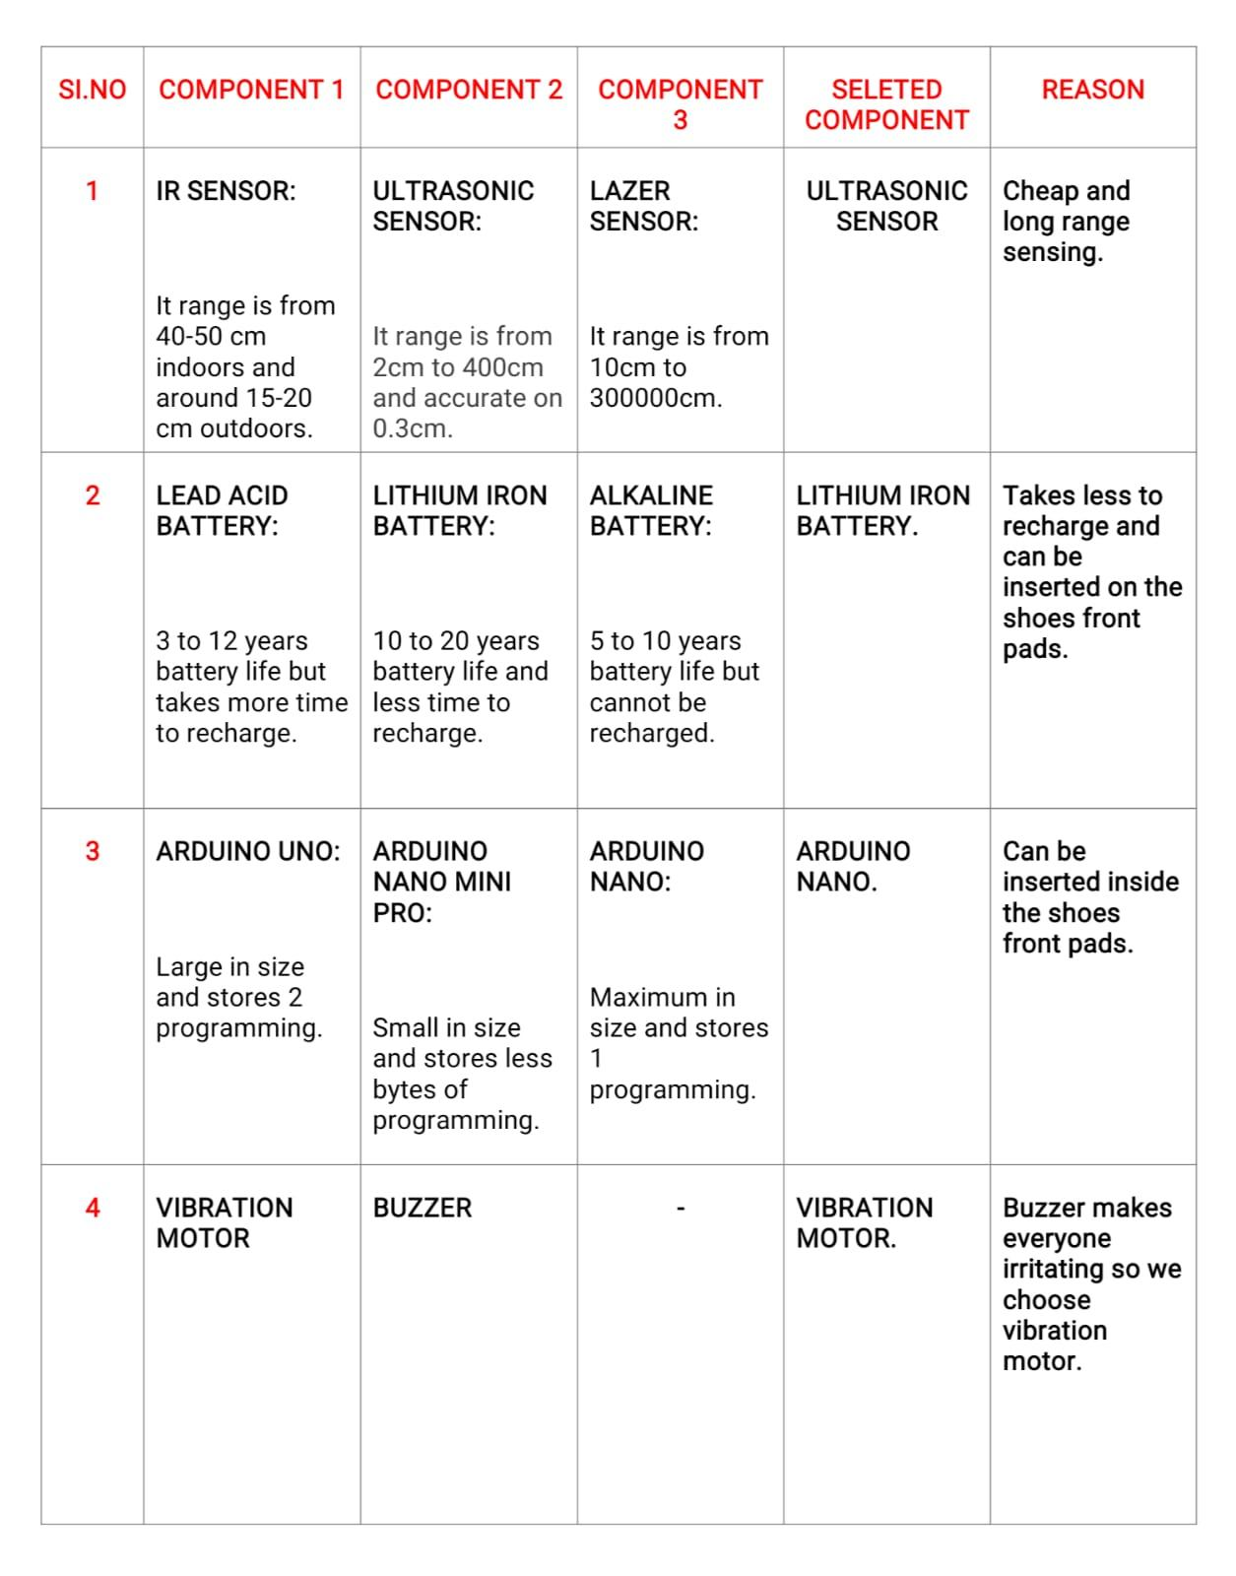

CHAPTER – 13

13.1 OUR PROJECT CAN BE IMPROVED LIKE THIS
- Can be used Atmega328p micro controller of the Arduino Uno.
- Can be used mini Lid AR Sensor alternative of ultrasonic sensor.
- Can be added camera on top of the toe and develop a app for them and detect the object using python and output will be given in android.
- Can be designed a special shoe for the person.
13.2 RESULT AND ANALYSIS:
DISTANCE(in cm) | TIME(in sec)
30-20 | 0.10
20-10 | 0.05
10-0 | 0.01

ANGLE(in ˚C) | DISTANCE(in cm) | YES/NO
0 | 0 | NO
30 | 0 | NO
60 | 30 | YES
90 | 30 | YES
120 | 30 | YES
150 | 0 | NO
180 | 0 | NO

CHAPTER – 14

CONCLUSION:
This project can be improved by adding Bluetooth connectivity and can be paired by using Bluetooth headset and give information using headset and may also can be attached camera and use python to detect objects.

